Assignment 3 – report

***Assignment details:***

In this assignment, we explored several architectures for the task of image super-resolution (SR) and compared the performance of each of them. We have compared the results in two ways, firstly by the metrics (e.g., PSNR, SSIM) and secondly by visual results after each epoch.

***Dataset details:***

We used [PascalVOC 2007](http://host.robots.ox.ac.uk/pascal/VOC/voc2007/VOCtrainval_06-Nov-2007.tar) dataset to create on-the-fly three images X (72X72), y_mid (144X144), and y_large (288X288). The dataset contains 5011 images, we dived the dataset into 4008 images (80%) for training and the rest 1003 (20%) for validation.

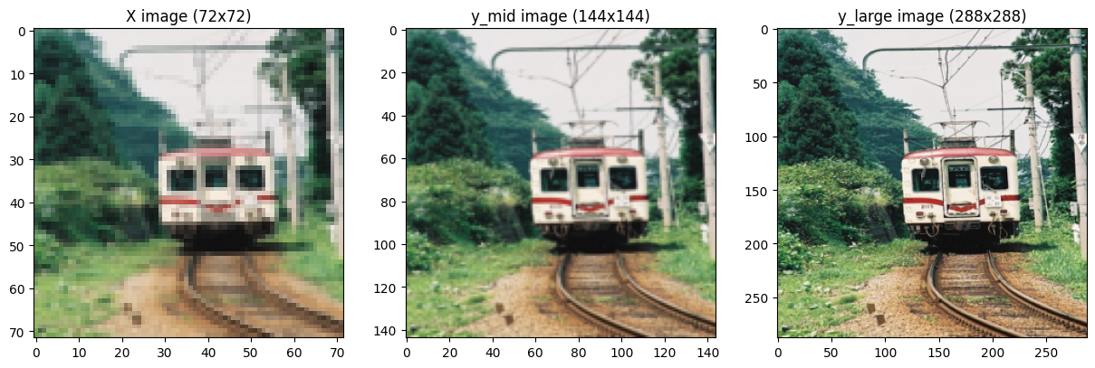

***Experiment:***

In general, the experiment was divided into 6 parts in each part we explored different architectures that share the same purpose of creating from a given input image with small dimensions (72X72) a larger image (144X144 and 288X228). I have monitored all my experiments with the Neptune.ai platform to evaluate each architecture performance. The platform helped me to evaluate the hypothesis and save the results.

***Part 1:***

Experiment 1 parameters:

|  |  |  |  |
| --- | --- | --- | --- |
| Number of epochs | Loss function | Learning rate | Evaluation metric |
| 7 | MSE | 0.001 | PSNR |

I used the first experiment to check the pipeline and model performance. Setting the maximum number of epochs to 15 and the patient parameter to 5, the patient parameter means the number of epochs the training loop keeps going without improvement of the loss function, eventually, the model stopped after 7 epochs. There was an improvement in validation loss only for 2 epochs. Looking over the loss graphs for training and validation seen like the model is overfitted but from the visualizations, I think that the model needs more epochs to converge.

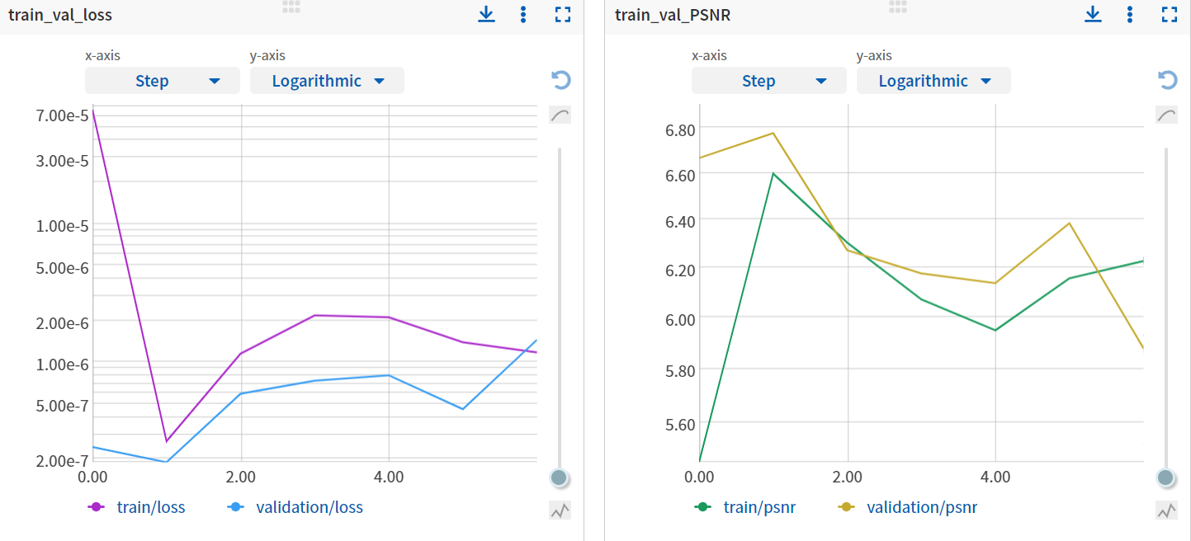

Experiment 1 gif

Experiment 2 parameters:

|  |  |  |  |
| --- | --- | --- | --- |
| Number of epochs | Loss function | Learning rate | Evaluation metric |
| 25 | MSE | 0.001 | PSNR |

I wanted to check the impact of releasing the patient constraint by allowing the model to train over 25 epochs. Inspecting 11 first epochs of the loss function of the validation dataset seen like the loss function would not converge and the visual result is far away from the target image. While the loss function of the training dataset immediately dropped near zero seen like the model immediately over fitted but it is not possible after only one epoch more over the PSNR for validation kept climbing. After a few more epochs the visual results were pretty good in comparison to the beginning.

***Conclusion***

The MSE as loss function doesn’t fit perfectly for the RS task may be because for each small error that we can’t see with our eyes the ‘punishment ‘is high. So instead of using MSE, I checked the performance of MAE.

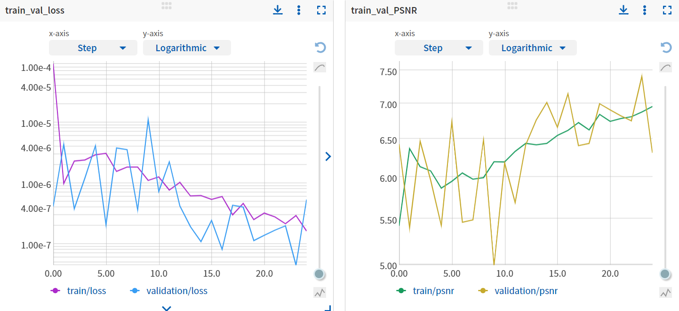

 Experiment 2 gif

Experiment 3 parameters:

|  |  |  |  |
| --- | --- | --- | --- |
| Number of epochs | Loss function | Learning rate | Evaluation metric |
| 25 | L1 (MAE) | 0.001 | PSNR |

In this experiment, I had better results both metrically and visually. Training loss behaves more like I had been used to up until now over all the assignments before. Still, the training loss drops fast and stays stable, but the validation loss also converges.

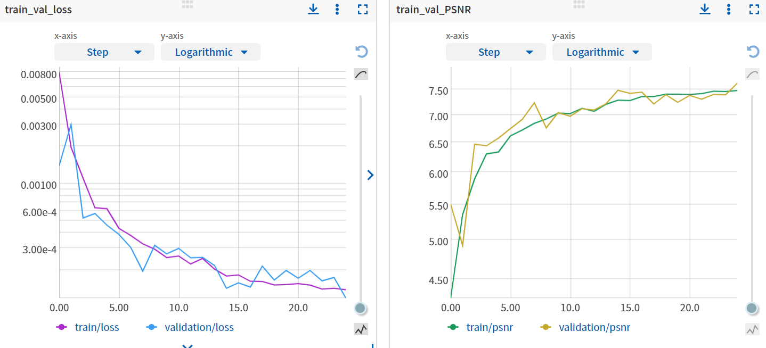

 Experiment 3 gif

***Part 2:***

All the following models produce two images’, medium and large dimensions outputs. To produce the medium dimension (144X144) the input image has been Upsampled once and another time to produce the large dimension (288X288). While training the model we need to consider that it is harder to create a larger image and more explicitly the loss probably will be more from the larger predicted images. However, I first created a benchmark result and experimented with other configurations. The loss function, for now, will be simply the sum of both predictions’ losses. max epochs 50 with a patient parameter of 10 epochs.

Experiment 1 parameters:

|  |  |  |  |
| --- | --- | --- | --- |
| Number of epochs | Loss function | Learning rate | Evaluation metric |
| 18 | L1 (MAE) | 0.001 | PSNR |

Training the model stopped after 18 epochs, which means the 8th epoch had the best validation loss. Compared to the visual and metrics results of the first model after 8 epochs I can’t see an improvement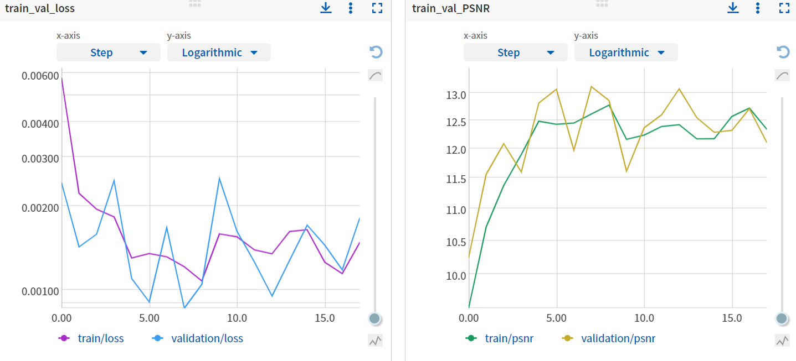, both predicted images blurrier. Moreover, the loss function didn’t converge.

Experiment 2 parameters:

This time I wanted to check the impact of weight loss, so the weight of the larger image loss will be 2 times more and the medium image stay the same as other configurations.

|  |  |  |  |
| --- | --- | --- | --- |
| Number of epochs | Loss function | Learning rate | Evaluation metric |
| 18 | L1 (MAE) | 0.001 | PSNR |

Training the model stopped after 39 epochs as we can see from the following graphs the loss function kept descending while the PSNR kept ascending, but the model didn’t improve significantly. In addition, good visual results are random and are not consistent.

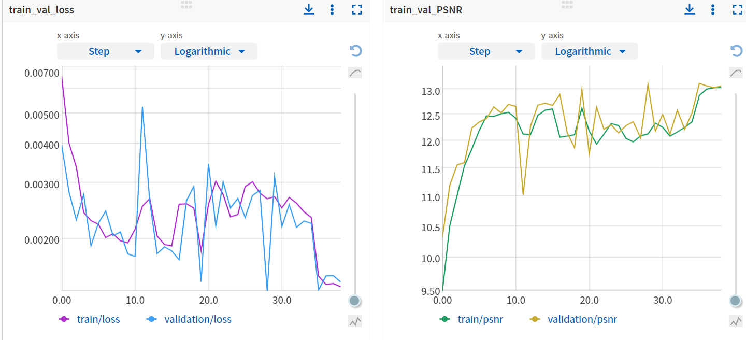

***Part 3:***

Up to this architecture, there were some of the visual results that were close to ground truth but now adding the ReLU activation function caused the output to lose a lot of data, as we can see. To mitigate this problem I use LeakyReLU.

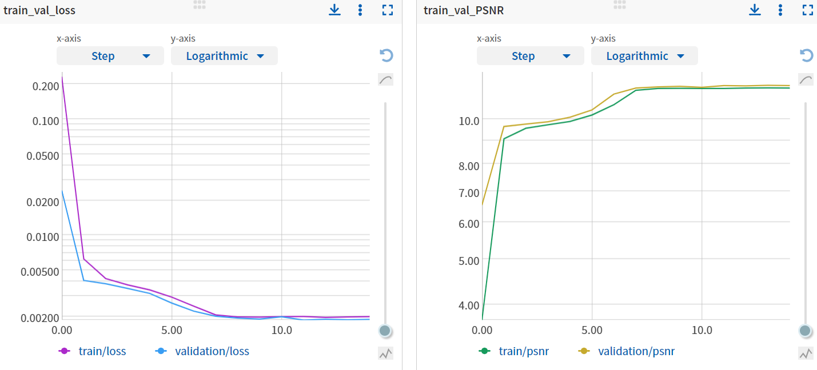Experiment 1 parameters:



Experiment 2 parameters:

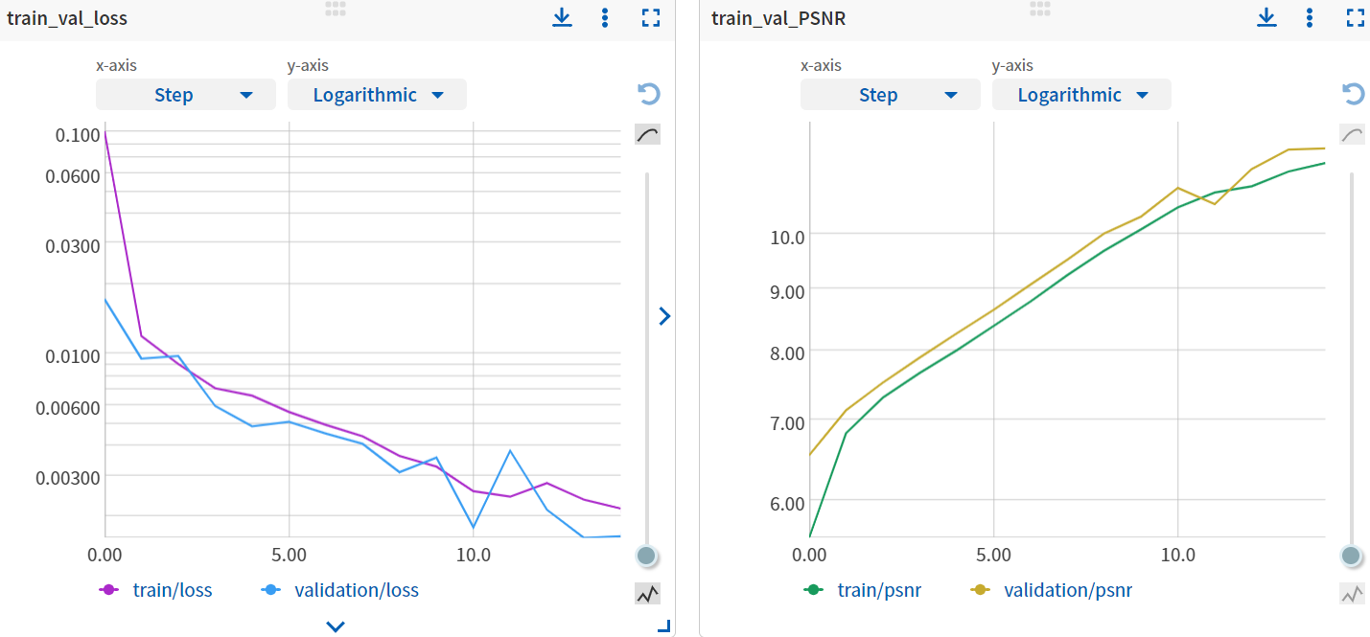The results are like the previous experiment.



***Part 4:***

Training the model stopped after 10 epochs and the visual results are like the previous model, but the performances are worse. The image is colored with random colors.

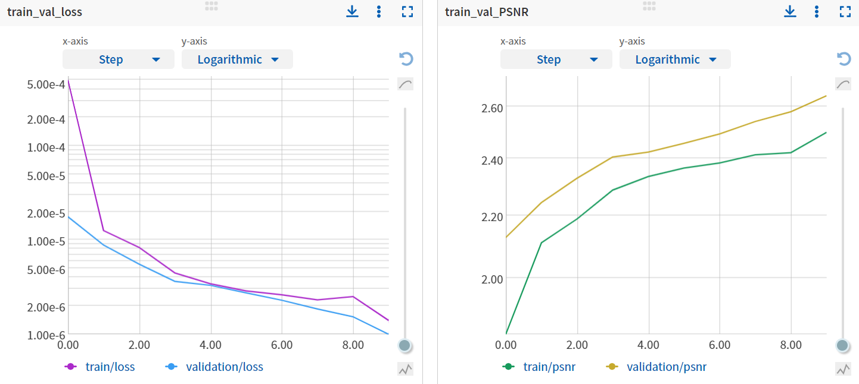

***Part 5:***

Adding more features didn’t help the model to achieve better results. The visual result is far away from the ground truth. Also, the metrics didn’t improve.

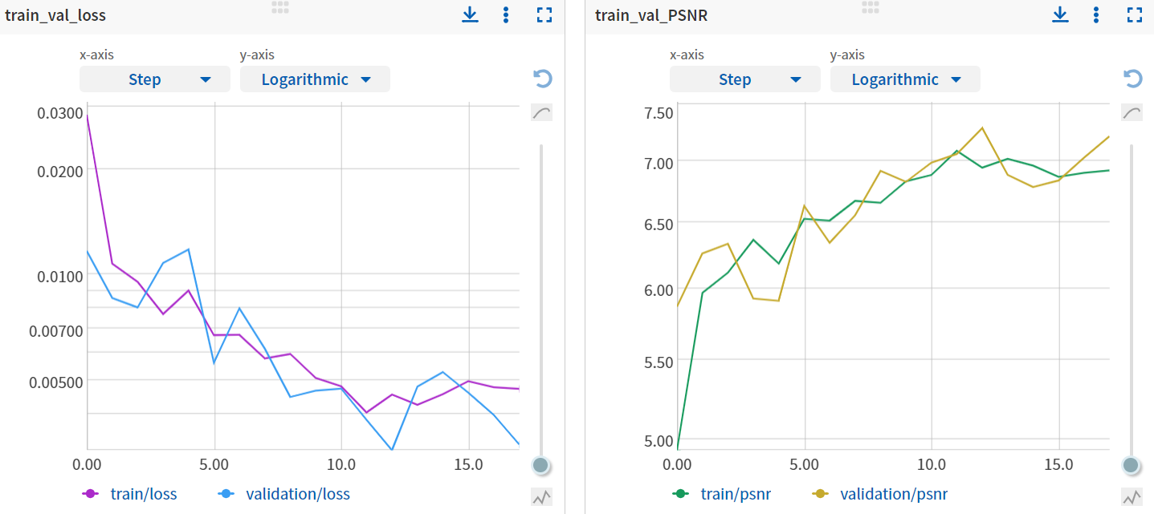



***Part 6:***

The loss function and PSNR results were better than the three last models, but the visualization results were as bad as those three. The prediction image was pixelated and the same problem was with the single color over the image.

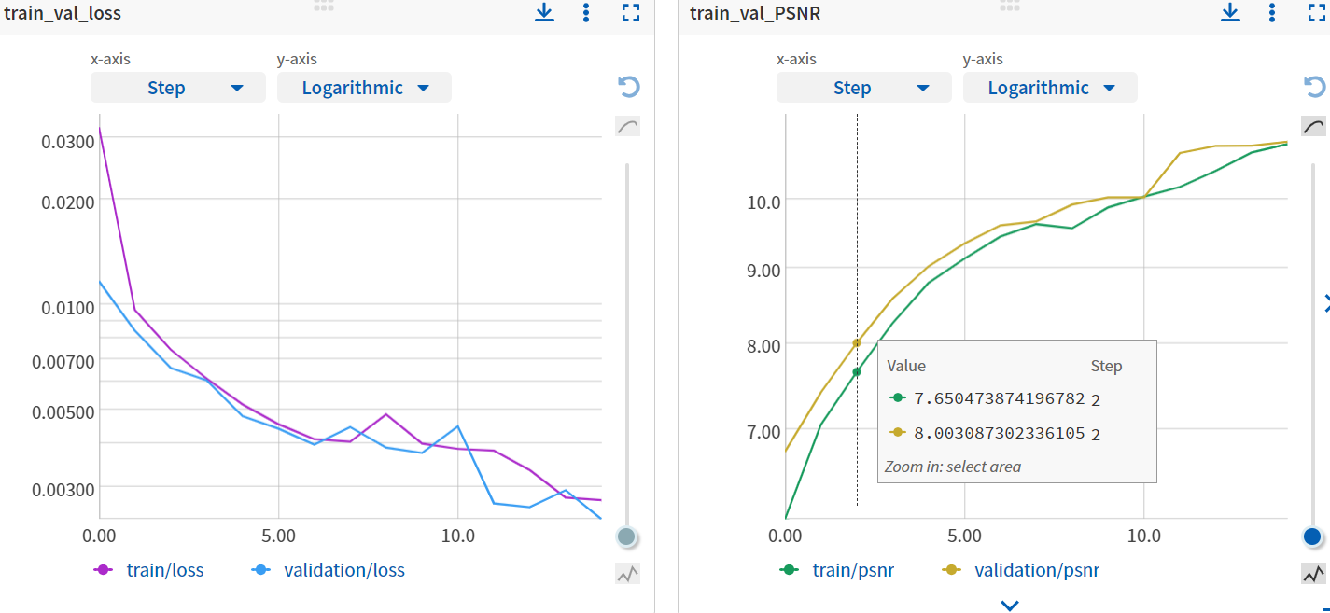

***Summary***

After experiencing different architectures and configurations it is seen from the results that the best architecture was the first even those it is the simplest of all models. I think that the most influential variable was the fact that the first model dealt with one output. The model is enough complicated to fit the task but when adding another output, we didn’t scale up the model enough so it can manage to produce a larger image with good quality. In general, I could see that the loss function didn’t fit the task.